Release Document – GenAI Amplifier

Application Name: GenAI Amplifier
Version: 1.0.0
Application Release Date: July 1, 2025
Version Release Date: July 1, 2025
Owner: Philippe Jardin
Project Manager: Debaditya Banerjee
Author: Naveen Somalapuri

Contents

Overview 2
Features & Enhancements 3
Architecture & Tech Stack 3
Known Issues & Limitations 4
Upcoming Enhancements 5
Release Dependencies 5
Rollout Plan 5
Feedback 6
Appendix 6

Overview
Business Problem
The manual process of creating Development Items (VOC, ROC, FD, TD) is time-consuming, prone to inconsistencies, and requires significant effort to ensure the documents follow the correct format. This often leads to delays in document generation, reduced productivity, and increased risk of errors in business-critical documentation.

Solution
The Gen AI Amplifier accelerates the creation of SAP development documentation by transforming customer business process inputs—via file upload or direct text entry—into high-quality, consultant-ready outputs.
It intelligently guides users through each phase of the development lifecycle, including:
- VOC (Voice of Customer)
- ROC (Response of the Consultant)
- Functional Design
- Technical Design
Leveraging Generative AI, the solution produces tailored, structured content and auto-generates a formatted Word document aligned with NDBS’s internal documentation standards

Expected impact
Accelerate SAP development documentation creation by 70%, transforming business inputs into formatted Development Object documentation using NDBS templates

Features & Enhancements
Feature | Description | Benefit
Agentic | Two-agent system integrated with Tavily search: one agent interprets the input and responds, the other searches the internet (if needed) and formats the final output | Enables an organized and automated workflow
Rag integration | Uses Retrieval-Augmented Generation for context-aware responses | Enhances accuracy and relevance of generated content
Word Templates | Automatically places Generated data into pre-defined Word templates | Prevents data misplacement and ensures structured output

Architecture & Tech Stack
- Model: Azure OpenAI GPT-4o (Preview)
- Frameworks: LangChain, FastAPI, Tailwind CSS
- Deployment: Azure Cloud (App Services)
- Frontend: HTML, CSS, JavaScript, Tailwind CSS
- Backend: Python, FastAPI
- Database: MongoDB, ChromaDB
- Security: Microsoft Entra ID Authentication (Identity Provider)
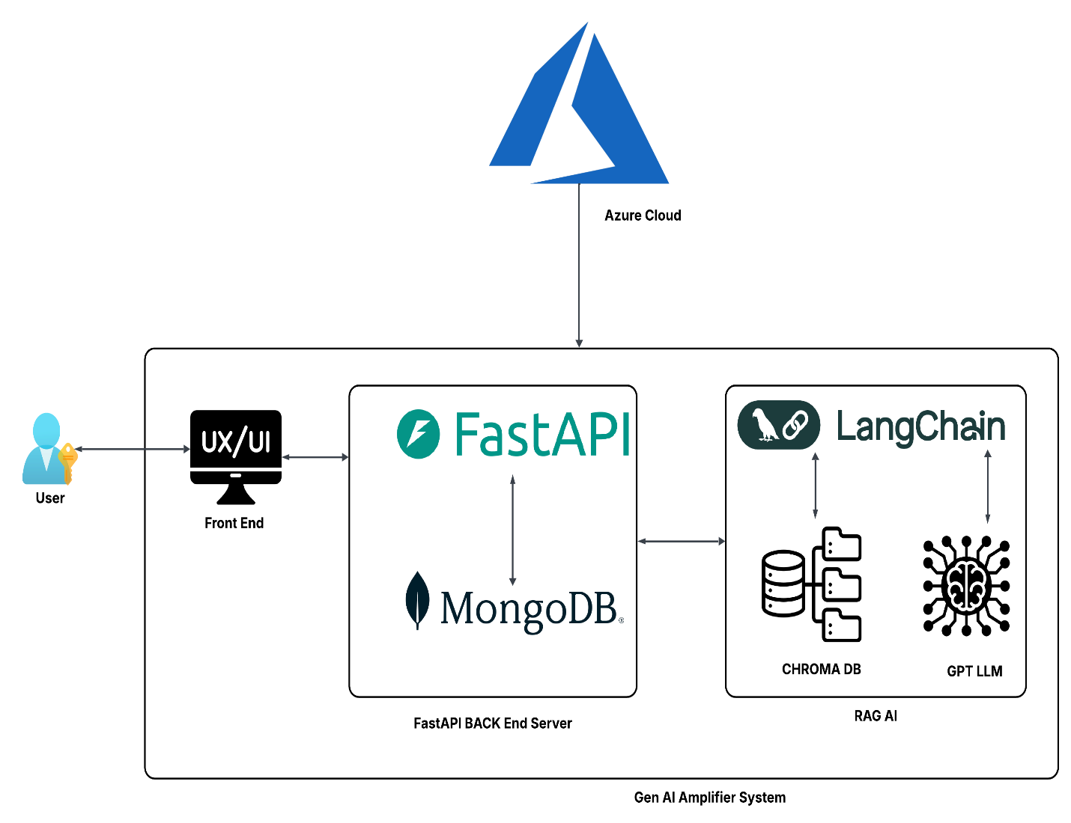

Known Issues & Limitations
- May hallucinate facts in low-context input
- Only documents in English language are supported
- Only notepad (.txt) format accepted for upload
- Output depends on the version of word template integrated with the model

Upcoming Enhancements
Enhancement | Description | Benefit
Light Theme | User Interface with a light theme | Enhances user experience and visual appeal
SharePoint Integration | Enable fetching data files from SharePoint | Improves accuracy and relevance using historical data
Image Integration | Retrieve images using RAG based on contextual input | Enhances the output document with visual illustrations
Tabular Information | Auto-populate all identified tables with relevant and accurate data | Reduces manual effort and ensures data completeness

Release Dependencies
- Azure OpenAI API access
- User authentication via Azure AD
- App Registration & Identity Provider Setup
- Azure Web App Deployment Environment

Rollout Plan
- Pilot Phase: 01 July 2025 – Pilot Testing version rollout for user testing and feedback gathering.
- Next Planned Release: v1.1 – TBD
- Full Rollout: TBD – All enterprise users
- Training & Onboarding: User guide link on application UI and in Appendix

Appendix
- Technical Documentation [Click Here]
- User Guide [Click Here]
- Feedback Form [Click Here]

